Appendix A FPGA Board I/Os: Switches, LEDs, and 7-Segment Displays

Table A-1: Pin assignments for the toggle (slide) switches
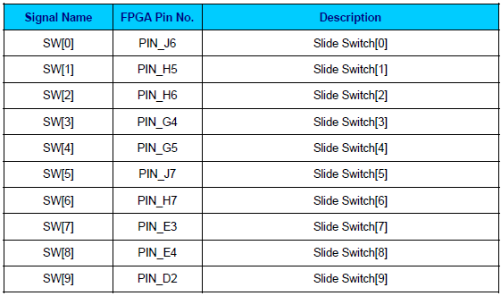

Table A-2: Pin assignments for the pushbutton (debounced) switches.
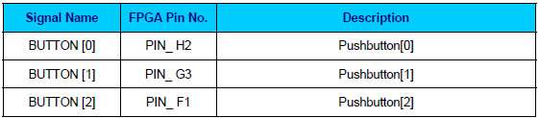

Table A-3: Pin assignments for the LEDs.
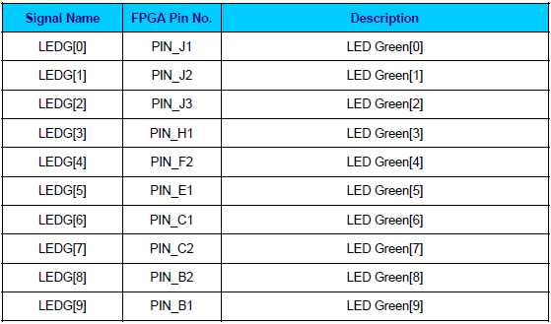

Using the 7-segment Displays

The DE0 board has four 7-segment displays. These displays are arranged into two pairs and a group of four, with the intent of displaying numbers of various sizes. As indicated in Figure A.1, the seven segments are connected to pins on the Cyclone III FPGA. Applying a low logic level to a segment causes it to light up, and applying a high logic level turns it off. Each segment in a display is identified by an index from 0 to 6, with the positions given in Figure A.2. In addition, the decimal point is identified as DP. Table A-4 shows the connections between the FPGA pins to the 7-segment displays.

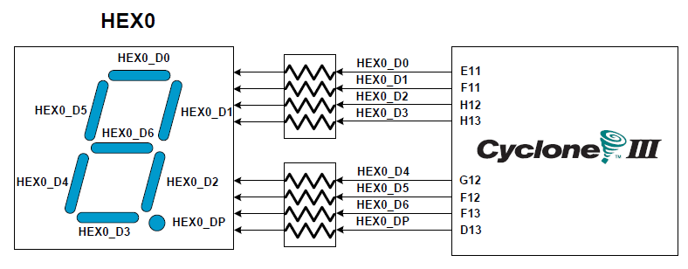

Figure A.1. Connections between the 7-segment displays and Cyclone III FPGA.

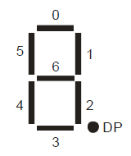
Figure A.2. Position and index of each segment in a 7-segment display.

Table A-4. Pin assignments for the 7-segment displays.
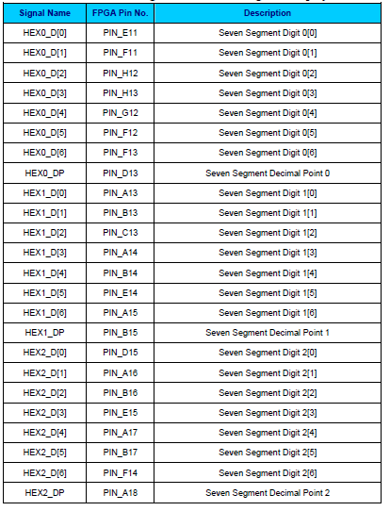

Using the Expansion Header

The DE0 Board provides two 40-pin expansion headers. Each header connects directly to 36 pins ofvthe Cyclone III FPGA, and also provides DC +5V (VCC5), DC +3.3V (VCC33), and two GND pins.
Among these 36 I/O pins, 4 pins are connected to the PLL clock input and output pins of the FPGA allowing the expansion daughter cards to access the PLL blocks in the FPGA. Finally, Figure A.3 shows the related schematics. The figure shows the protection circuitry for only two of the pins on each header, but this circuitry is included for all 72 data pins. Table A-5 gives the pin assignments.

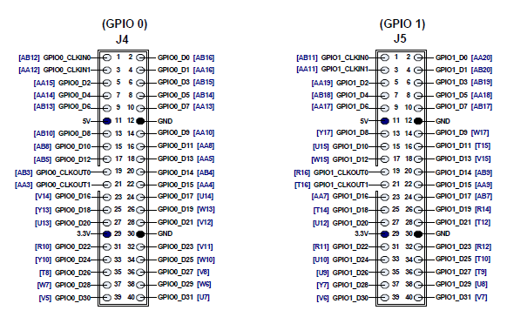
Figure A.3. I/O distribution of the expansion headers.

Table A-5. Pin assignments for the expansion headers.
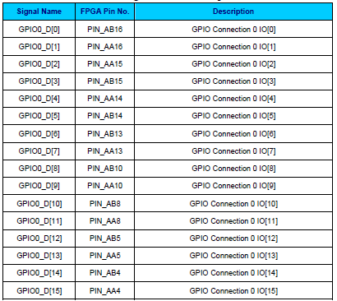

Clock Circuitry
The DE0 board includes a 50 MHz clock signals. This clock signal is connected to the FPGA that are used for clocking the user logic. In addition, all these clock inputs are connected to the phase lock loops (PLL) clock input pin of the FPGA allowed users can use these clocks as a source clock for the PLL circuit.

The clock distribution on the DE0 board is shown in Figure A.4. The associated pin assignments
for clock inputs to FPGA I/O pins are listed in Table A-6.

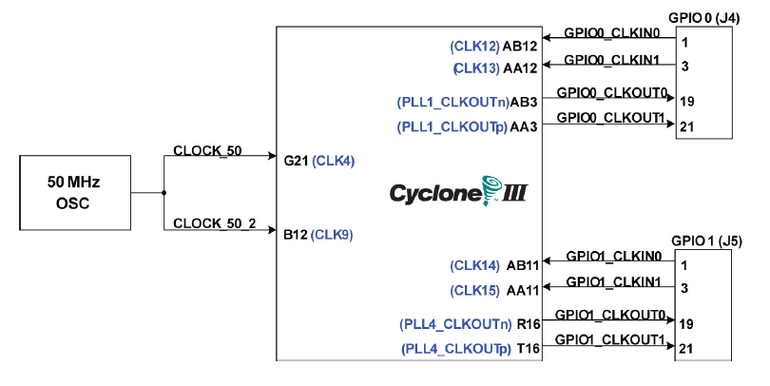
Figure A-4. Block diagram of the clock distribution.

Table A-6. Pin assignments for the clock inputs.
